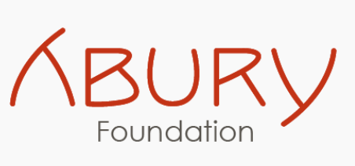

**Looking for Passionate Hospitality Trainers: Opportunities at ABURY Hospitality Women’s Academy.**

**We are looking for passionate local trainers from Marrakech and the surrounding area!**

Do you want to share your knowledge, empower women, and help shape the next generation in tourism? Then become part of a unique educational project that opens up new opportunities for women!

The ABURY Foundation has been implementing educational projects in Morocco since 2013. It’s latest project, the **ABURY Hospitality Academy,** is a unique place created especially for young women! Together with our amazing partners – the École hôtelière de Lausanne (the NGO EHLsmile) and many local hotels and riads – we have developed a program that equips our students with the fundamental skills they need to confidently enter the hospitality industry.

For our ABURY Women’s Hospitality Academy in Marrakesh, we are looking for dedicated trainers available between September 1, 2025, to February 30, 2026, who can accommodate our course schedule and commit the necessary time to fulfill their training responsibilities alongside other professional engagements.

* **English**
* **Computer Skills**
* **Housekeeping**
* **Culinary Arts & Gastronomy**
* **Service & Guest Relations**
* **Communication & Soft Skills**
* **Hygiene & Cleanliness**

**Mission**

To provide accessible, high-quality, and culturally relevant vocational education in hospitality through a blend of classroom instruction, industry experience, and personal development, fostering confidence, skills, and employability for young women in Marrakech.

**General Framework:**

* Freelance contract
* Paid on an hourly/daily basis
* Great, vibrant location at Emerging Business Factory (Sidi Ghanem)
* Motivated team of experts in their field

**What you should bring:**

* **Professional experience** in your subject area
* **Passion** for teaching and empowerment
* Ideally, experience or understanding of the **tourism and hospitality sector**
* Strong **communication** skills
* **English skills** are a plus
* A **collaborative spirit** and openness to intercultural learning

**We especially encourage women to apply**—women who are eager to share their expertise and support young women on their path to independence.

**Be a role model. Be a mentor. Be part of ABURY.**

**Apply now and help shape the future!**

👉 **Please send us your application with a motivation letter and your contact details to: academy@abury.org**