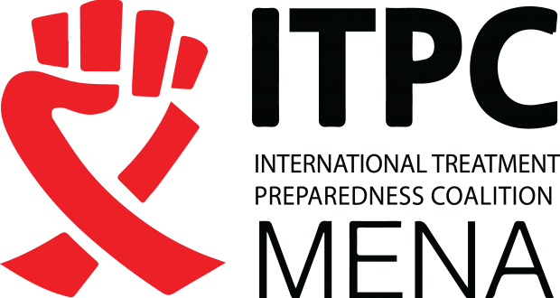

**Call for Applications for the ADP (Activist Development Program) on HIV and Leadership Training in MENA Region**

**\*(Egypt, Lebanon, Morocco, Jordan, and Tunisia).**

ITPC-MENA is delighted to announce the launch of our HIV and Leadership training program designed for young activists. This program is crafted to enhance the capacities of young activists to become leaders in the fight against HIV and AIDS.

HIV is a disease that affects millions of people worldwide. We believe that by strengthening your knowledge and understanding of HIV, you can become a significant player in the battle against this disease in the MENA region, specifically in the following countries (Egypt, Lebanon, Morocco, Jordan, and Tunisia).

The HIV and Leadership training program offers you an opportunity to develop your leadership skills and contribute to the HIV fight. You will learn:

* The fundamentals of HIV and AIDS, including modes of transmission, symptoms, and available treatments.
* How to promote HIV prevention, including safe sexual practices and regular testing.
* How to support people living with HIV, including combating stigma and discrimination.
* How to conduct effective HIV awareness campaigns among your peers and the community.

We are looking for dynamic and dedicated young leaders to participate in this program if you:

* Are between 18 and 30 years old and have an interest in fighting HIV and promoting sexual and reproductive health.
* Have a good command of the Arabic and/or French and English languages.

And if you meet at least two of the following qualification criteria:

* Have three years of experience in HIV activism or social justice within a national network or community organization (e.g., a national network of PLHIV).
* Hold a degree in a field related to health or behavior sciences (e.g., public health, medicine, pharmacy, psychology, sociology).
* Have participated in a national, regional, or international HIV conference (e.g., IAS, ICASA) – proof should be submitted at the time of application.
* Have been recommended for this training by an ITPC-MENA partner, a regional network coordinator, and/or a national or regional partner such as MENAHRA, MENAPUD, MENA Plus, SIBA, RANAA, etc.
* If you wish to develop your leadership skills, we strongly encourage you to apply.

To apply, please send us an email to the following address: zakaria.bahtout@itpcmena.org, copying othmane.marrakchi@itpcmena.org, with the following information:

* Your full name
* Your age
* Your city and country of residence
* Your phone number
* Your experience in leadership and community engagement
* A motivation letter explaining why you want to participate in this HIV and Leadership training program.

Applications will be assessed based on the relevance of leadership and community engagement experience, motivation, and commitment to the fight against HIV.

**The deadline for applications is set for November 30, 2024, at 12:00 PM (Morocco Time). Successful candidates will be notified via email.**

We look forward to receiving your application and are eager to work with you to strengthen your leadership and commitment in the fight against HIV.