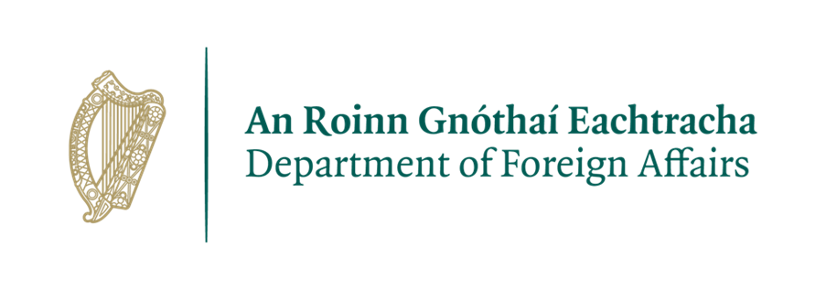

**Re-advertised Recruitment Notice –**

**Policy and Research Officer, Embassy of Ireland, Rabat**

***The Embassy of Ireland in Rabat, Morocco opened in October 2021 to promote and protect the values, interests and economic well-being of Ireland and its people in Morocco and Tunisia. We do this through promoting Ireland’s political and economic interests, fostering the political relationship between Ireland, Morocco, and Tunisia, and soon Mauritania, working with the local Irish community and promoting Irish culture.***

The Embassy of Ireland, Rabat is seeking a highly motivated, enthusiastic and hardworking person with excellent communication and interpersonal skills to fill a full-time Policy & Research Officer position.

The role of Policy and Research Officer is to support the Embassy, by contributing to promote the values of the Irish people, analysing Moroccan and Tunisian policy positions, particularly in foreign policy; deepening Ireland’s engagement with Morocco and Tunisia and providing administrative support in the Embassy, as required.

This role involves a wide variety of tasks as detailed below, including supporting the wider work of the Embassy in line with the Embassy’s Business Plan and more broadly with Ireland’s Department of Foreign Affairs’ high-level goals and objectives.

**Roles and Responsibilities:**

The precise range of duties will vary over time according to the requirements of the Embassy. Some out-of-hours work may be expected. This role will include, but may not be limited to the following activities:

* Researching policy, political, social and economic developments and providing reporting and analysis;
* Providing written analysis and reporting;
* Compiling press summaries and reports;
* Providing regular economic, trade and other reports, monitoring trade figures and investments;
* Supporting the development and launch of an Irish Business Network and of enhanced links between business in Ireland, Morocco and Tunisia;
* Developing and maintaining a good understanding of Ireland’s policy positions;
* Attending and reporting on briefings, meetings, conferences and events;
* Organising meetings, events and official visits;
* Providing administrative support to diplomatic officers, including managing calendars and

contacts, keeping records, processing requests, responding to queries and maintaining

information flows;

* Providing high quality translations into Arabic, French and English;
* Drafting official communications;
* Other duties as required from time to time and directed by Head of Mission and Deputy Head of Mission.

**Required skills, qualifications and experience:**

* Candidates must have a University degree in relevant field
* The candidate must demonstrate using work based examples of providing excellent **interpersonal skills**, being persuasive, **working in a team** but also dealing effectively with people in external organisations;
* The candidate must provide evidence of flexibility, efficiency and effectiveness showing strong **writing skills**, attention to detail, able to work under pressure and to manage multiple tasks;
* The candidate should provide examples of being solutions-oriented, and **committed to delivering results**, including by adapting approach if necessary;
* Languages: French, Arabic and English languages, candidates should be fluent in all three (language test may be included as part of the shortlisting process);
* The ability to work well under pressure;
* Great attention to detail and the ability to multitask and work reliably to deadlines;
* Good working knowledge of Microsoft Office suite (Outlook, Word, Excel) and social media platforms including Facebook, Twitter and Instagram;
* The ability to work on own initiative and be flexible about taking on new work areas;

***All applicants must have a legal right to reside permanently and work in Morocco.***

**Desirable skills and experience:**

* A good understanding of the role of the Department of Foreign Affairs and the Embassy of Ireland;
* The successful applicant will work alongside other local employees of the Embassy, and will report directly to the diplomatic staff in the Mission. Previous experience in a diplomatic mission is desirable, but not essential.

**Terms and conditions of employment:**

|  |  |
| --- | --- |
| Start date: | As soon as possible |
| Location: | Embassy of Ireland, Rabat |
| Contract duration: | 1 year fixed, with one month probationary period. |
| Working hours: | Up to 44 hours per week including the possibility of some evening and weekend work.  Individuals unavailable to work out-of-hours on occasions should not apply for this post. |
| Salary: | Salaries are paid direct to a bank account; therefore, the successful candidate must have a bank account. |
| Annual leave: | 20 days per annum and a mixture of Moroccan and Irish public holidays observed. |
| Eligibility: | Candidates must have a legal right to reside and work permanently in Morocco and will be subject to local employment and taxation law. |
| Closing date: | 18 May 2023 |
| Selection process: | Please send a completed application form (attached) to[**RabatEmbassyExternalMail@dfa.ie**](mailto:RabatEmbassyExternalMail@dfa.ie), with Policy Research Officer Application in the subject line. Depending on the number of applications received, a short-listing of candidates to be called for a **competency-based** interview may be undertaken based on the Essential/Key Requirements above. |

**General Data Protection Regulation:**

All personal information received will be kept in line with GDPR guidelines.

**Security Clearance for Local Staff**

Police security clearance will be sought in respect of individuals who come under consideration for appointment. Enquiries may also be made with the police force of any country in which the applicant under consideration for appointment resided. If unsuccessful, this information will be destroyed. If the applicant subsequently comes under consideration for another position, they will be required to supply this information again.

***Please note that canvassing will disqualify applicants.***

***The Embassy of Ireland in Rabat is committed to a policy of Equal Opportunity***