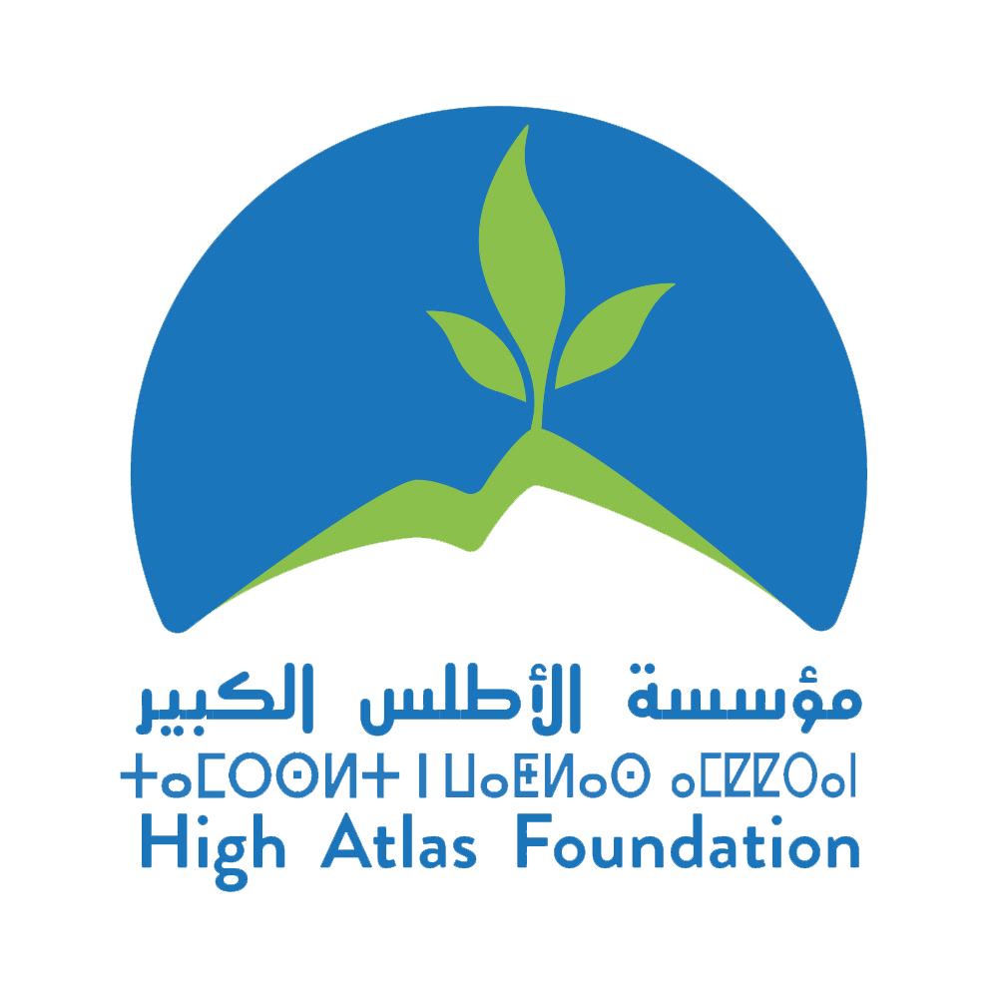

Position Title: Chief Operating Officer (COO)
Supervised by: President of Operations
Work Hours: 40 hours
Location: Marrakech, Morocco

Basic Function of Position

Founded in 2000 by former U.S. Peace Corps Volunteers, the High Atlas Foundation (HAF) works to establish development projects in Morocco that local communities design and manage. A U.S. 501c3 nonprofit association and a Moroccan civil association, HAF uses a participatory approach that includes beneficiaries as active partners in every step of the development process, from prioritizing goals to project implementation and management to monitoring and evaluation. Key to this approach is the facilitation of community planning meetings where beneficiaries together determine the types of projects they want to undertake and create action plans, which are most often in the areas of fruit tree agriculture, clean drinking water, and women’s and girls’ income-generating cooperatives.
HAF has experienced exponential growth over the past two years and continues to grow, with the organization poised to increase its number of employees to nearly 100, up from 23 in 2019. HAF’s team is currently implementing programs across the development spectrum with financing and in partnership with Moroccan governmental agencies, U.S. donors such as USAID, the U.S. Embassy, the U.S. Forestry Service, and key private sector partners. As of January 2022, HAF will begin the implementation of its newest program with financing from the European Union in Morocco.
HAF announces the opening of the position of Chief Operating Officer, who will be a member of the senior management team responsible for achieving the strategic goals of the Foundation. The COO resides in Marrakech and has responsibilities in the critical areas of finance, operations, and development. The COO supervises HAF’s program staff toward effective and efficient implementation of programs, identifying and facilitating cross-programmatic cooperation for enhanced outcomes. The role will initially focus primarily on the advancement of internal organizational development, as the COO will be the primary responsible person for centralizing administrative and human resources functions. They will also play a key role in the organization’s fundraising and communications efforts.

Specifically, the COO supports the President in:
- Planning and managing annual budgets;
- Conducting annual planning processes to update the strategic plan and budget in a collaborative process with the HAF staff;
- Developing and implementing human resources policies and plans; overseeing HAF contracts, agreements and MOUs;
- Supervising and coordinating the professional development of program staff, building on their abilities, education and experience;
- Developing organizational capacity for succession planning and to scale-up with Moroccan and international partners;
- Identifying and developing grant opportunities, and overseeing grants management;
- Managing efforts with key external stakeholders and contributors;
- Supporting and promoting the concept of Corporate Social Responsibility/Investment;
- Coordinating events strategic planning and with partners, contributors and associations;
- Developing and overseeing participatory education/training of private and public, local to national groups and individuals, and HAF development projects;
- Assessing the performance of HAF projects and programs;
- Developing and maintaining a team-oriented work environment; and

Summary of responsibilities

Financial Management
- Plans and manages annual budget; ensures that the allocation of resources aligns with available funding and supports the strategic and operational priorities of the foundation
- Interprets financial results for the board and nonfinancial staff
- Monitors expenditures against budgets and funding obligations
- Oversees providers for legal, accounting, healthcare, and other services required to support operations and financial reporting
- Oversees grant budgeting, compliance and reporting with Program Directors
- Ensures compliance with tax regulations
- Conducts annual audit and 990 preparation

Administration
- Conducts annual planning process to update the strategic plan and budget in a collaborative process with the HAF staff
- Establishes operational calendar to plan for and manage critical projects and deadlines
- Develops and strengthens operational practices and procedures
- Manages contracting, negotiation and invoicing

Human Resources and Organizational Development
- Oversees the development and implementation of human resources policies and protocols that are commensurate with modern best practices and are compliant with U.S. and Moroccan law
- Identifies and monitors resource needs
- Manages recruitment and personnel contracts
- Develops an equitable and effective system for performance management;
- Identifies and coordinates opportunities for the professional development of staff
- Implements plans for organizational development and capacity building
- Cultivates a team-oriented work environment

Fundraising
- Supports and promotes the concept of Corporate Social Responsibility/Corporate Social Investment in the Moroccan private sector and internationally, particularly as it relates to carbon offsetting through social programs
- Identifies and develops grant opportunities, contributing to proposal development targeting public, private, and civil sectors, and supervising key staff members, interns, and volunteers in this process
- Researches and co-develops approaches to strategically gaining financial support
- Monitors and oversees follow up of fundraising opportunities

Communications and Events
- Supports executive-level outreach with key stakeholders and contributors
- Increases institutional awareness through strategic communications and messaging
- Supports the planning and coordination of strategic events
- Represents HAF at external events
- Authors and contributes to articles related to HAF’s human development mission

Program Oversight
- Supports and implements institutional partnership agreements and MOUs
- Supports implementation of all programs
- Collaborates with the HAF program and development-communications teams to identify program funding needs and align promotional materials and funding proposals
- Contributes to participatory development projects, training, education, and materials

Monitoring and Evaluation
- Monitors strategic plan progress, results, and opportunities
- With the President, oversees program teams in assessing performance and impact
- With development team, ensures that proposals for program funding reflect realistic and achievable results and objectives
- Works with program teams to ensure compliance with HAF and donor policies
- Conducts program evaluations as needed, considering close-outs requirements outlined in award contracts
- Review reports to institutional donors and other stakeholders as needed

Requirements:
- 10-15 years of related international development experience reflecting progressive responsibility within the non-profit, private, or public sector
- Experience working in a Moroccan context is required
- Advanced degree in a related field, such as sustainable, international, or organizational development, nonprofit or business administration, finance, human resources management, or communications
- Demonstrated ability to influence, advance, and support the strategic growth needs and visibility of an organization
- Proven track record of supporting the capacity needs of a multicultural staff while ensuring 100% compliance with organizational and donor policies and procedures
- Excellent interpersonal, written, and public speaking communication, including among staff, beneficiaries, and stakeholders at the local, national, and international levels
- Spoken and written fluency in English, Arabic, and French are required
To apply, please send CV and cover letter to sanae@highatlasfoundation.org by January 17, 2022 with
“Application for HAF Chief Operating Officer” in the subject line.

